**COVID-19 DATA ANALYSIS USING BIGDATA HADOOP**

1.Collect the covid-19 data from internet , for data analysis.

2.Open VMware for terminal.

3.create the file in local, using command.

4.File name as ‘covax’.

5.Load the CSV data of covid19 in file ‘covax’ and save it .

6.To save ctrl+x –yes , the file will be saved.

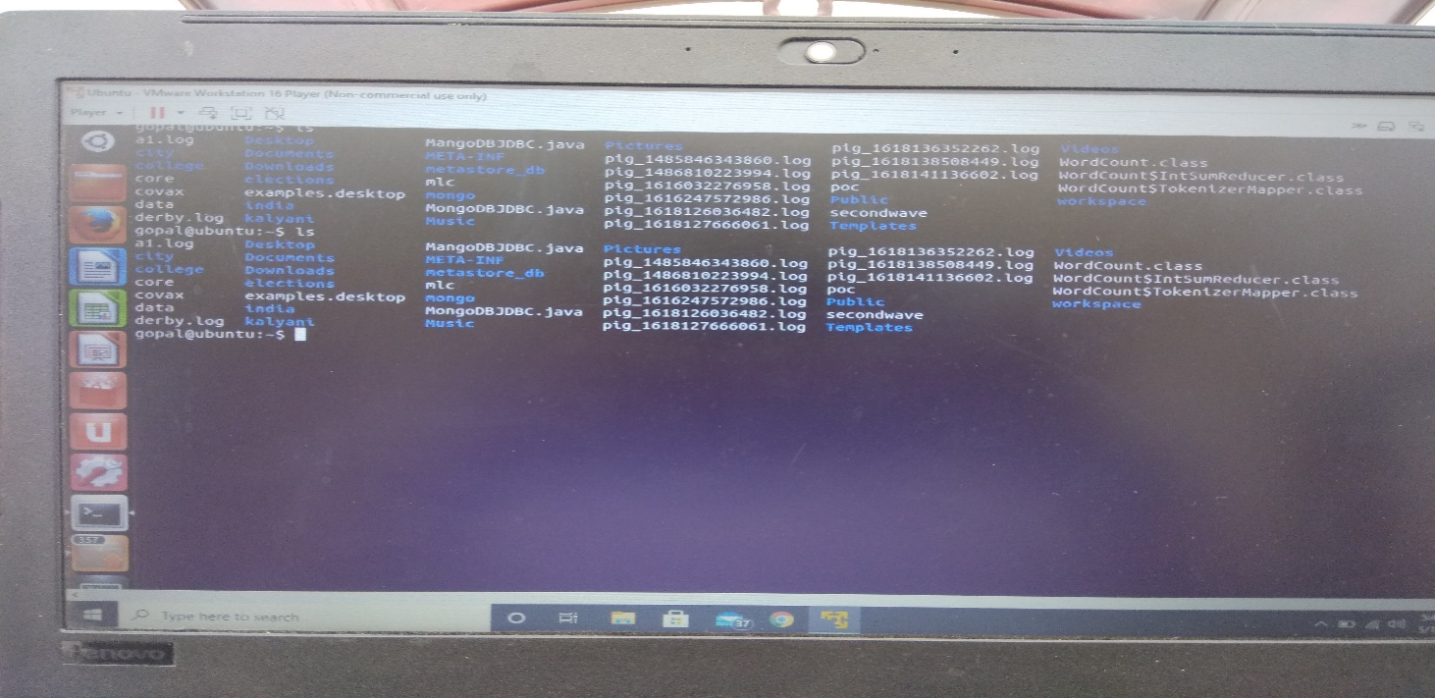

7.Start Hadoop by using a command start-all.sh

8.Hadoop will start.

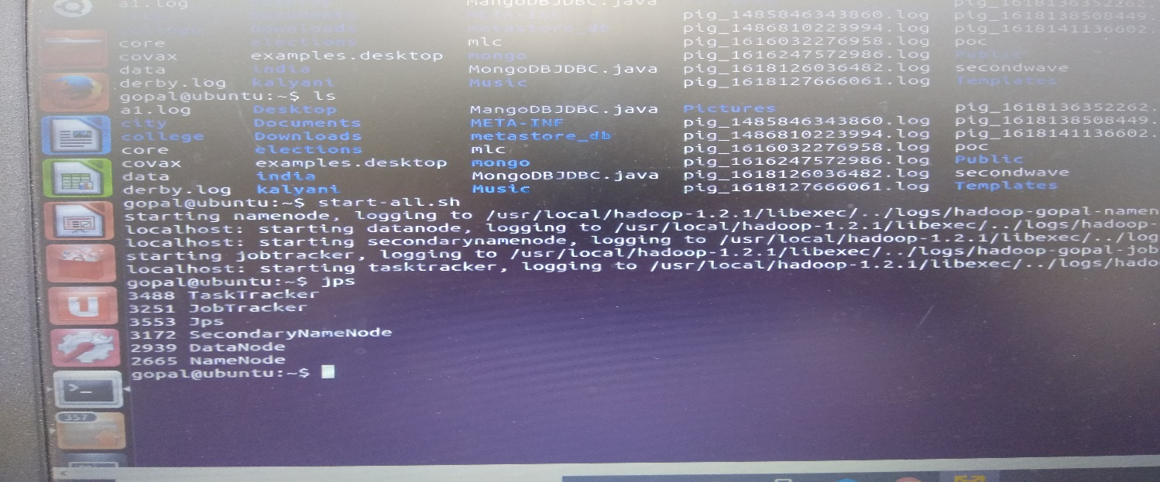

9.Move the local file into Hadoop.

10.Open the brower open you Hadoop host check whether data is in your file or not.

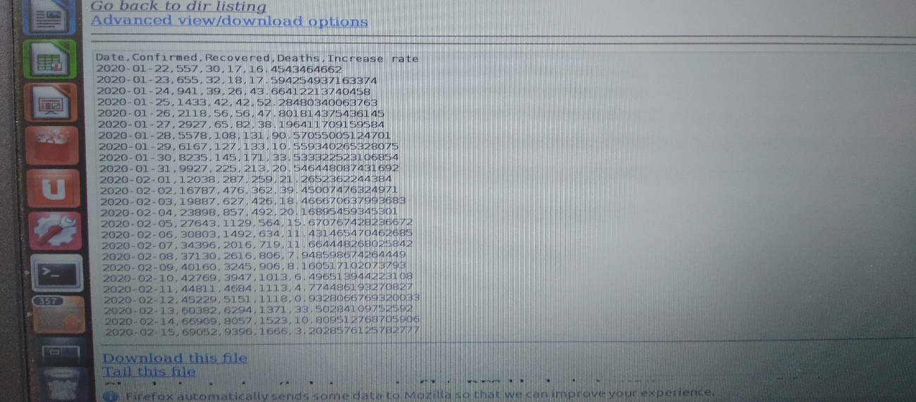

11.Then next start HIVE. The Hive grunt will be open.



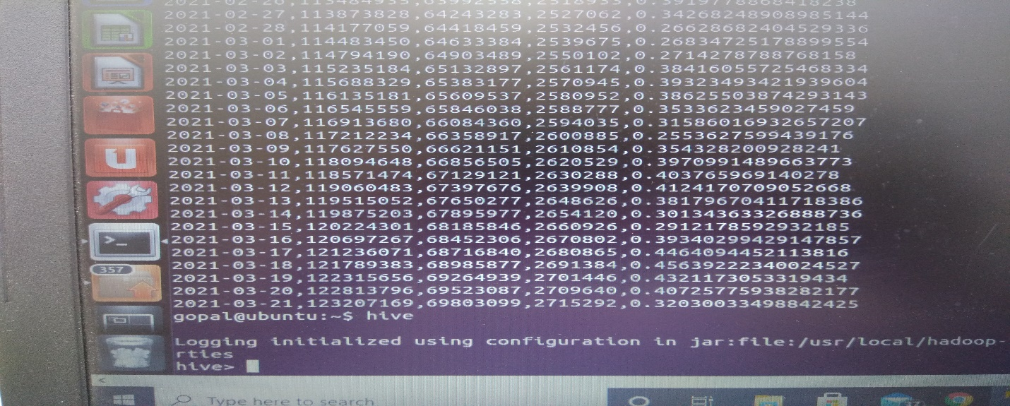

12.Check any available Databases and tables.

13.Show databases is a command to check DB.

14.Show Tables is a command to check Tables.

15.Create a Database ,use that database for a table.

16.Create a Table and load the data in a table using path command.

17.Start using queries.

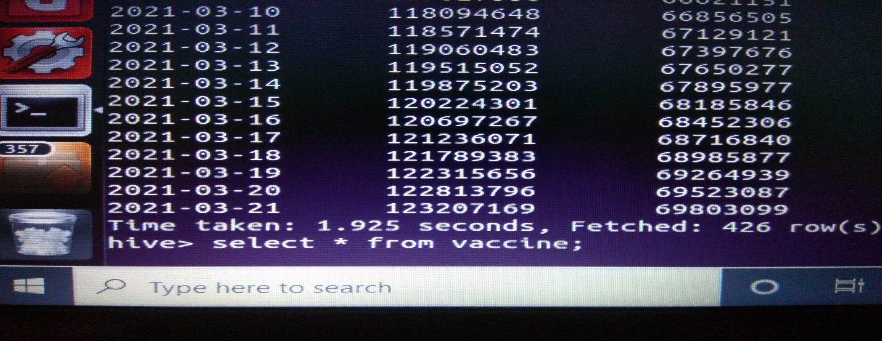

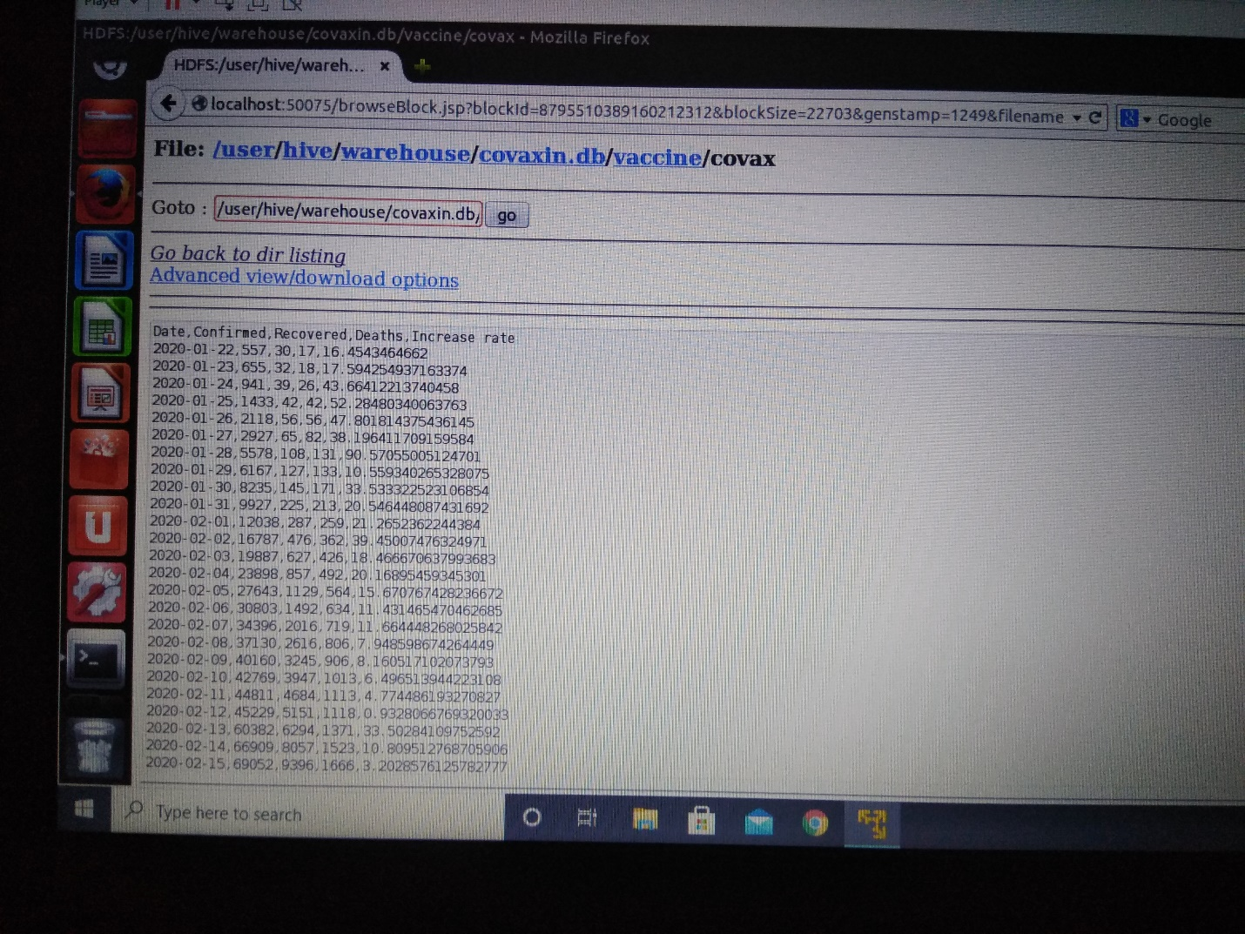

18.Quit the hive and stop the Hadoop.